BIOLOGY
Paper1
MARKING GUIDE

1 | B | 11 | B | 21 | A
2 | C | 12 | B | 22 | C
3 | D | 13 | D | 23 | B
4 | A | 14 | C | 24 | D
5 | C | 15 | C | 25 | A
6 | B | 16 | D | 26 | C
7 | B | 17 | A | 27 | B
8 | D | 18 | B | 28 | D
9 | D | 19 | C | 29 | A
10 | A | 20 | D | 30 | C

SECTION B
Answer ALL questions in the spaces provided.

- The graph below shows the response of drinking one litre of water by a healthy person. Study it and answer the questions that follow:

- (i) Describe the graph. (05 marks)

- Initially; urine output decreased rapidly to zero(0) hours before water intake;
- In the first 30 minutes; / From 0 hours to ½ hours; there was a rapid / sharp drastic / exponential increase in urine output; (up to 2000cm³ / 30minutes)
- From ½ hours to 1 hour; there was a gradual / slow / sluggish increase in urine output;
- From 1 hour to 2 hours; there was a rapid / drastic / sharp / exponential decrease in urine output;
- From 2 hours to 2 ½ hours; there was a gradual / slow increase in urine output;
- From 0 hours to ½ hours, urine output increased rapidly; because of excess water in the body after water intake; / there was less water re-absorption due to less production of anti diuretic hormone; / vasopressin into blood stream; and much water had to be excreted in urine;
- From ½ hours to 1 hour urine output increased gradually; because there was less water in the body to be excreted; / more of the antidiuretic hormone had been secreted into blood stream; making kidney tubules more permeable to water; hence less urine output;
- From 1 hour to 2 hours urine output decreased rapidly; because water level in the body had decreased at a higher rate;
- From 2 hours to 2 ½ hours urine output increased gradually; because of additional water from body metabolism;
- (i) Osmo-regulation (01 mark)

(ii) ¼ hours; / 15 minutes;
(ii) A drop of water level in the body is detected by the hypothalamus of the brain; which stimulates the pituitary gland; to secrete antidiuretic hormone; which flows into blood stream to kidney tubules; making them more permeable to water;
- More water is reabsorbed from the fluid in the kidney tubules into blood; leading to production of a smaller volume of concentrated yellow or darker urine;
- Blood becomes more concentrated than body cells; causing them to lose more water; by osmosis; cells shrink; causing the person to feel more thirsty often; due to dehydration;

Alternatively
- Water will diffuse out from body cells by osmosis;
- Cells will become dehydrated and shrink;
- Cellular metabolism will stop;
Total marks 20

- Codominance; because there is equal expression of genes; due to the blending of both alleles; / non of the genes is dominant over the other; resulting in the formation of intermediates;
- Let allele for red flowers be R;
Let allele for white flowers be W;
Parental phenotype; red flowers X; white flowers
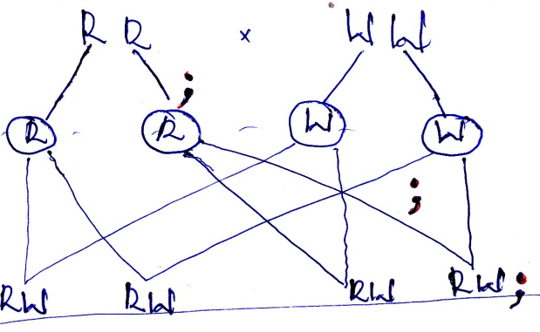
Parental genotype;

Gametes;

Random fertilization

F₁ genotypes

F₁ Phenotypes All pink flowers;
Selfing F₁ to obtain F₂ off spring;

Parental phenotype; Pink flowers x pink flowers
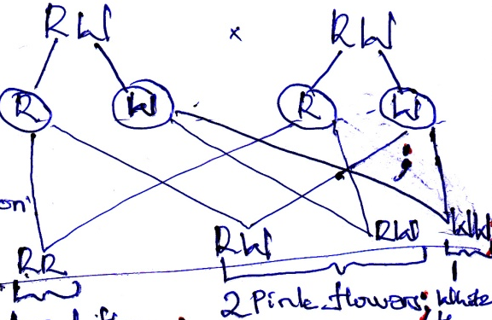
Parental genotype;
Meiosis
Gametes;
Random fertilization
F₂ genotypes

F₂ phenotypes red flower;
Proportion of white flowered; ¼;
Percentage of being white flowered ¼ x 100%
= 25% total = 10 marks

- (a) Explain the effects of each of the following on the rate of transpiration.
- Low light intensity. (02 marks)
Rate of transpiration is reduced; because stomata narrowly opens; leading to less evaporation from the plant; and low heat to evaporate water;
- High humidity. (02 marks)
Rate of transpiration becomes low; due to saturation of air; with vapour around the stomata; preventing further loss of water vapour;
- High wind velocity. (02 marks)
Increases rate of transpiration; because high speed of wind blows away water vapour; from leaf surface; creating spaces that can take up more water vapour;

(b) State the principle on which the instrument that measures the rate of transpiration works. (04 marks)
Rate of water loss; determines rate of water absorption; which is also directly proportional to the rate of movements of air bubble; introduced to the instrument; (total 10 marks)
SECTION C
Answer TWO questions from this section
Answers are to be written in the answer booklets provided.

- (a) Is the discharge / addition of unwanted / toxic substances/ energy into water
bodies; in such quantities that they can cause harm to aquatic life;
(b) un treated sewage; causes algal bloom / reduces oxygen in water due to decomposition causing suffocation of aquatic organisms;

- Agro chemicals; kill aquatic organisms;
- Soil / silt; blocks gills of fish causing suffocation;
- Silt also reduces water levels; causing death of some aquatic organisms;
- Soap / detergents; kill aquatic life;
- Hot water from factories / industries; kill aquatic organisms;
- Polythene; reduces light penetration and so reduce rate of photosynthesis; visibility of aquatic organisms;
- Oil spilage; causes suffocation of aquatic organisms since it prevents entry of oxygen;
- Radioactive substances; cause mutations to living organisms;
- Pollutant ½ mark
- Explanation 1 mark @
Total 15 marks

- (a) Describe any three(3) characteristics that can distinguish the following
feathers.
- Quill (03 marks)
    - Hard / long / strong / quill
    - Large vane;
    - Hard / rigid shaft
    - Few loose barbs
    - Superior and inferior umbilicus;

- Contour. (03 marks)
    - A lot of / much loose barbs;
    - Soft quill
    - Flexible rachis;
    - Short vane;
    - Large after shaft;
    - Short quill
1 mark @
3 marks

(b) Describe how the wings are moved up and down during flight in a bird.
(09 marks)
Wings move up and down during upstroke; and down stroke; using antagonistic muscles pectoralis major and minor;

Upstroke
- Pectoralis minor muscles contract;
- Pectoralis major muscles relax;
- Wing is raised;
- Flights feathers on the wing spread; and wing become porous; reducing air resistance;

Down strong
- Pectoralis minor muscles relax;
- Pectoralis major muscles contract;
- Wing is pulled down and backward; as it pushes against air underneath;
- Bird gains height; and moves forward;
Total 15 marks
Alternatively
Wings move up and down during up stroke, and down stream;using antagonistic pectoralis major and minor muscles;

Up stroke

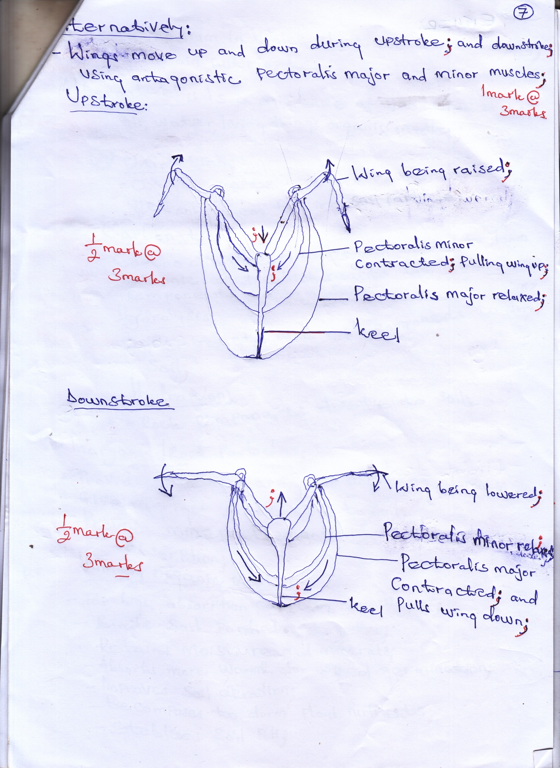

Down stroke

- (a) Is a medium in which plant roots are anchored; and obtain nutrients;

Alternatively
Is a mixture of weathered rocks; air, water, living things organic matter;

(b) oxidation
Oxygen reacts with rock components weakening them to form soil particle;

Carbonation;
- Carbon dioxide dissolves in water to form carbonic acid which reacts with rock components to form soil;

Hydrolysis
Water reacts with rock components to form soil;

- Inorganic / Rock particles;

- Provide surface area for anchoring of roots;
- Give a rigid frame work to soil;
- Provide mineral elements to soil for plant absorption;

Humus / organic matter;
- For high absorption capacity for water;
- Binds soil particles together;
- Retains moisture and minerals;
- Absorbs more warmth for seed germination;
- Improves soil aeration;
- Decomposes to form plant nutrients;
- Stabilizes soil pH;
Soil water
- Moistens soil making it favourable for survival of wing organisms;
- Dissolves mineral salts making them readily available for plant absorption;
- Raw material for photosynthesis;
- Provides turgidity to herbaceous plants;
- Dissolves carbon dioxide forming carbonic acid which weathers rocks;

Soil air;
- Provides oxygen for respiration of soil organisms and plant roots;
- Provides oxygen needed for seed germination
- Carbon dioxide is used in photosynthesis;
- Nitrogen fixed in soil forms nitrates;

Soil living organisms
- Aerate soil through tunnels they make;
- Improve on soil drainage
- Decomposes litter to form humus;
- Add fertility to soil by fixing nitrogen;
12 ½ marks
Max 10 marks

- (a) State the structural differences between pulmonary artery and pulmonary vein. (03 marks)

Pulmonary artery | Pulmonary vein
- Narrow lumen  - Thick walled  - More elastic fibres  - No valves | - Wider lumen  - Thin walled  - Less elastic fibres  - Has valves

(b) Describe how blood flows through the heart of humans. (08 marks)

- Deoxygenated blood flows into the heart from the rest of the body; through the vena cava; to the right atrium; / auricle; which contracts to pump blood to the right ventricle; via the tricuspid valve;
- Right ventricle contracts; and pumps blood to pulmonary artery; through semi – lunar valves into lungs; for oxygenation;
- Oxygenated blood from lungs flows back into left atrium; via pulmonary vein into left ventricle; through bicuspid valve;
- Left ventricle contracts; and pumps blood via semilunar valves into aorta; to the rest of the body;

(c) In which ways are red blood cells adapted to their function? (04 marks)

- Lack nucleus; to provide a large surface area for packing haemoglobin; carriage of oxygen;
- Have thin membrane; to reduce diffusion distance for respiratory gases;
- Numerous to increase surface area for carrying respiratory gases;
- Contain haemoglobin; which has a high affinity for oxygen;
- Flexible membrane; which make them squeeze easily through capillary networks;
- Have enzyme carbonic anhydrase; which transports carbon dioxide;

END

